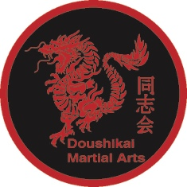
Doushikai Martial Arts Membership Form

Student Name:
Parent name if student under 18:
Address:

Postcode:
Phone number:
Date of birth:
Email:
Any previous martial arts experience?
If so style and grade achieved:
Do you suffer from any medical condition or have any injury that may affect your training? If so please specify:
Do you consent to your picture or your child’s picture to be used on the Club’s website of Facebook page? | Yes/No
How did you hear about our club?

Declaration
- I promise to uphold the true spirit of Karate-do and never to use the skills and techniques that I am taught against any persons, except for the defence of myself or others, in the instance of danger or unprovoked attack, or in support of law and order.
- I understand that it is my responsibility to inform the instructor of any health problems, injuries, or if I am taking any medication or intoxicating substances that may affect me and my training before the start of any lesson/seminar.
- I acknowledge that the practice of any martial art/self-defence training involves risk of injury.
- I agree to abide by the rules of the Doushikai Martial and declare that the information given above is true and complete.

Signature of student (or parent): ___________________________

Date: ___________________________

